Group No. & Names: 36  [Name A], [Name B] | Title: From Collision to Consequence

- Objectives
Our video asks one question: once someone is hurt in a road crash, what decides whether they walk away, or are killed or seriously injured (KSI)? Its message is that a 76% fall in road deaths since 1979 hides a gap. People with nothing protecting them fare 2–3× worse in identical conditions, and that risk multiplies with bad conditions on the same person.
We used the UK Department for Transport’s STATS19 data^{[1]}, which records police-reported injury crashes in Great Britain. It links collision, vehicle and casualty tables, covering 12.1 million casualties from 1979 to 2025. We used the full history for trends, and a joined 2021–2025 extract of 652,821 casualties to explore causes. Our main measure is the KSI rate per 1,000 casualties, and we treat groups of under 200 casualties as unreliable.

- Contributions
Member | Video presentation | Other contributions
[Name A] | Opening, headline, twist, obvious guess, matched conditions (about 2:49) | [Add what you built]
[Name B] | Risks multiply, wider patterns, closing (about 2:59) | [Add what you built]

- Novelty
Our main contribution is testing a claim visually, instead of only describing a trend.
- Add-versus-multiply test (Figure 1): a log-scale parallelogram predicts the worst case both ways, 390 per 1,000 if risks add and 582 if they multiply. The actual figure of 569 settles it.
- Pictures as data marks: a speedometer dial with speed-limit signs on its rim shows the groups pulling apart, and that the 70mph dip exists only for protected road users. Vehicle silhouettes^{[4]}, all drawn the same length, mark each KSI rate by where the vehicle’s front sits.
- Week as a clock: 168 time slots wrap round a clock, so the overnight peak reads as one dark zone across midnight. Every ring has the same area, so Monday isn’t shrunk by the circle.
- Condition matrix: a dot grid replaces long labels across eight matched comparisons.
- One line that opens and closes: the average line splits into exposed and protected groups, then merges back at the end, so the movement carries the argument.
- Paired hexagon maps (Figure 2): built from crash coordinates on a real coastline^{[3]}, they show that people get hurt in the cities but die on the empty roads.
- Gestalt colour system: one dark red always marks the harmful side, on every chart, and one outline groups exposed road users in the waffle chart.
- Interaction and sound: a year slider shows the gap changing over 47 years. A tick for each year, and silence before the key reveal, use the medium instead of decorating it.

- Technical Challenges and Innovation
We built the analysis and animations in Python: pandas and NumPy for data, matplotlib and seaborn for charts, Plotly for the interactive chart, and ffmpeg for video. We assembled the slides and recorded our narration in PowerPoint.
- Scale: the full tables hold 10–16 million rows each, so we read them in chunks, using only the columns needed.
- Changing codes: up to 2004, most motorcycles used older codes. Left out, 840,853 casualties counted as protected and created a false jump in 2005. We confirmed the codes in DfT’s data guide^{[2]} and corrected the grouping.
- A misleading map: our first map of KSI rates mostly showed police recording differences, from 147 per 1,000 in London to 359 in Scotland. We mapped deaths per casualty instead, because deaths are recorded consistently, using 37 km hexagons on both maps, each holding at least 200 casualties. We also re-ran our main results with DfT’s adjusted severity. The matched multiples stayed at 2.0–3.3×.
- Synchronised animation: clips are drawn frame by frame from the data at 720p, with each reveal timed to the script. The slider sequence uses real frames captured from the interactive chart in a browser.
- Coastline alignment: we fitted the conversion from longitude and latitude to the crash data’s grid using the crash records’ own coordinates, accurate to about 3 metres.
- Perception: a log scale shows multiples fairly, the gap chart starts at zero so the gap isn’t exaggerated, the deprivation butterfly chart shares one central axis instead of using a second y axis, and the speed dial’s scale starts at the hub’s edge so low values don’t bunch together.

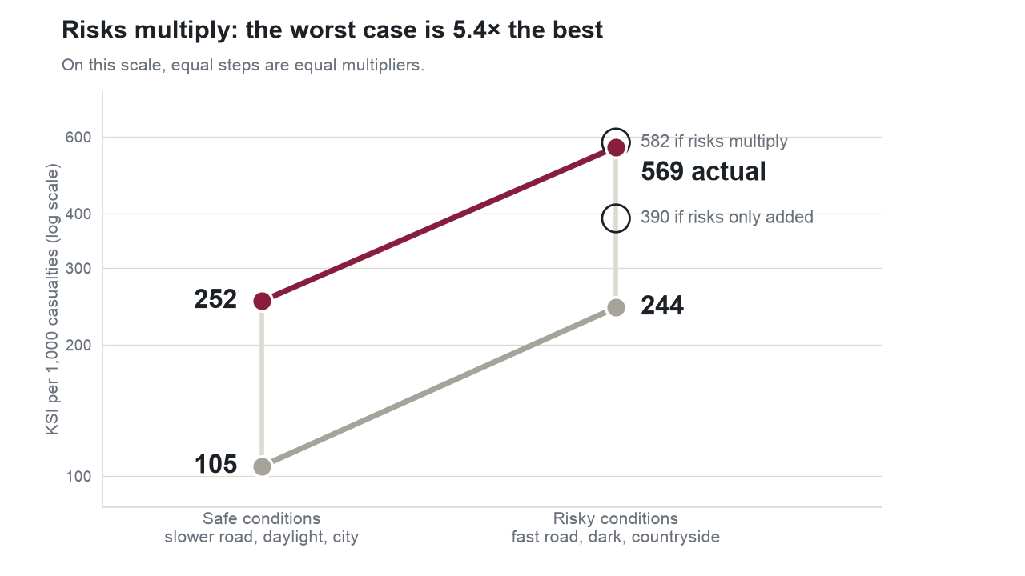
Figure 1. The add-versus-multiply test: KSI per 1,000 casualties on a log scale.
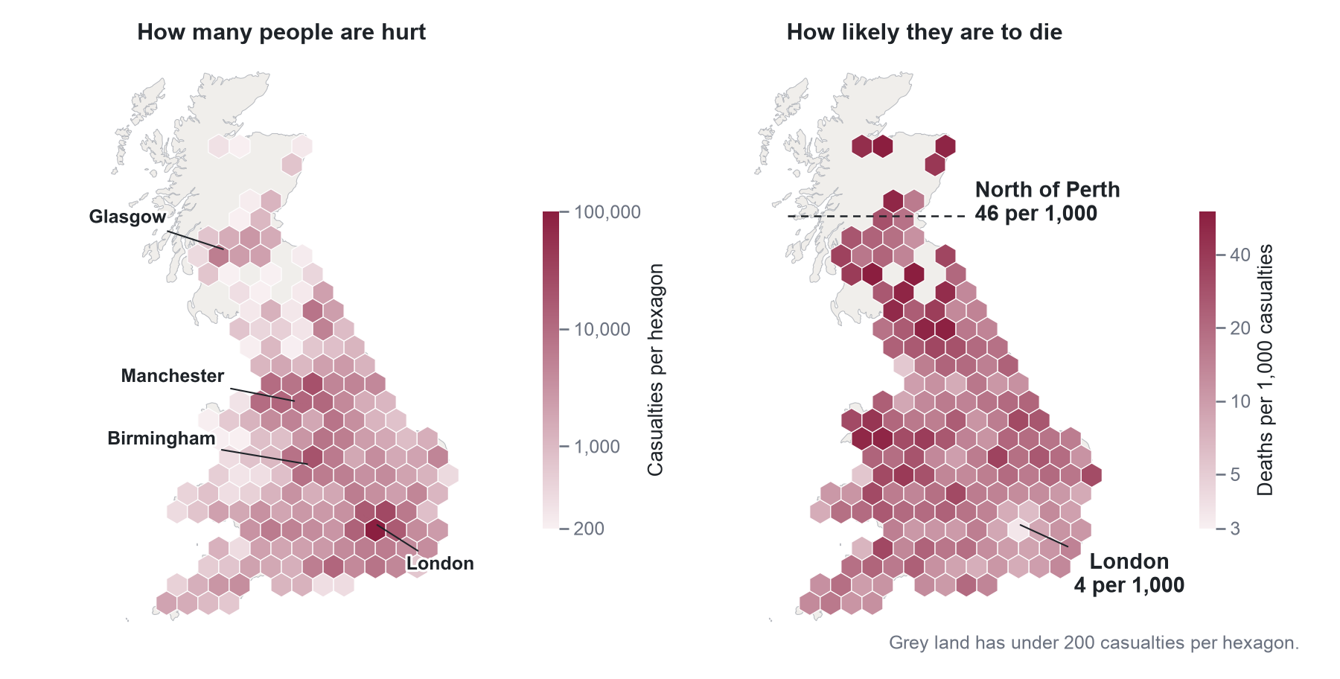
Figure 2. Where people are hurt, and how likely they are to die: 46 per 1,000 north of Perth, 4 in London.

- References
- Department for Transport. Road Safety Data. https://www.data.gov.uk/dataset/cb7ae6f0-4be6-4935-9277-47e5ce24a11f/road-safety-data
- Department for Transport. Road Accident Data GB: Data Guide. June 2006. https://doc.ukdataservice.ac.uk/doc/6254/mrdoc/pdf/6254userguide.pdf
- Natural Earth. 1:10m Admin 0 Countries (public domain). https://github.com/nvkelso/natural-earth-vector
- Vehicle silhouettes: Phosphor Icons (MIT), Temaki (CC0), Microsoft Fluent Emoji (MIT) and Google Material Symbols (Apache 2.0). https://github.com/iconify/icon-sets
- [Add the course sources you used for Gestalt principles, with weblinks.]

